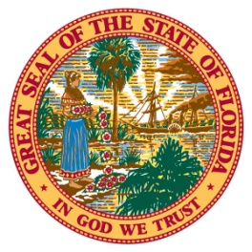
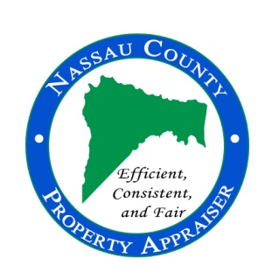
96135 Nassau Place, Suite 4, Yulee, FL 32097 Phone: 904-491-7300 Fax: 904-491-3629 www.nassauflpa.com
OFFICE OF THE
NASSAU COUNTY PROPERTY APPRAISER
A. Michael Hickox, CFA
FOR IMMEDIATE RELEASE June 1, 2022
Contact: Kevin Lilly, 904-491-7302
“Home Values in Nassau County Reach Record Appreciation Levels”
Nassau County, FL – In my forty plus years in the real estate and appraisal industry, I have never experienced a real estate market like the current one. There are a record number of people migrating to Florida from other states due to previous lock downs, lower taxes, better schools, and the ability to work remotely. This has created a shortage of available housing for sale and inflation has driven building cost to record levels, making existing homes more attractive. For the second year in a row, almost all properties offered for sale are receiving multiple offers within the first few days, resulting in bidding wars and sales prices above the original list price. However, this market is dramatically different than the market we experienced from 2004 to 2008 which produced a collapse of the housing market. The current market is a user’s market opposed to a speculative market, which was driven by loose lending practices and speculative building. This market is being driven by buyers with cash looking to improve their quality of life by relocating to the Great State of Florida. The record level of appreciation is a direct result of limited supply and increased demand, which is simple supply and demand economics. Tracking and trending sales into the first quarter of 2022 indicate some neighborhoods on Amelia Island have seen a 50% or more annual appreciation.
The supply chain issues, staffing, fuel prices, and inflation have hurt many small businesses and commercial properties. Our job is to measure what, if any, the loss of business had on the value of the real estate as of January 1, 2022. Some properties are owned and purchased for their ability to produce income. That income drives the value of the real estate. Due to the lockdowns in 2020 and 2021, many income producing properties, such as hotels, restaurants, and movie theaters, lost value due to a forced shutdown. Most made a comeback in 2021, but the full-service hotel industry, for example, is not expected to reach 2019 income levels until 2024. Even after considering the reductions in value to some commercial properties because of the pandemic, value in Nassau County has once again reached record levels.
Due to the migration of out of state buyers and increased demand for residential properties, the total market value for the County has reached a new record high of over $20.5 billion, which is an increase of over 18% from the previous year. The taxable value has surpassed the previous year exceeding $12.6 billion, almost 14% above last year.
The City of Fernandina Beach is projected to see a taxable value increase of 12.5%, bringing their taxable value to about $3.37 billion.
The Town of Callahan is estimated to have its taxable value increase to $137 million, up by over 10% from last year.
The Town of Hilliard is expected to see about an 11.3% increase in taxable value, bringing that value to over $129.5 million.
The primary responsibility of the Property Appraiser’s office is to produce a tax roll which is fair and equitable. Florida Statutes require we identify and appraise every parcel in the County to a “Just or Fair Market Value” each year. This is the starting point for Florida’s property tax system and the funding source for local government. I am often asked, “How do you determine the just or market value of my property?”. Florida is a 100% assessment state. This means each year we are required to estimate the “fair market value” of a property based on the most probable price it would have sold for if offered for sale in an open market. Consequently, we run sales and statistical analysis for different neighborhoods, markets, and property types to determine a sales ratio. These ratios reflect a comparison of a property’s sales price and its current just or market value. We make changes to values based on the sale ratio for their property types and market. Because we mass appraise, the Department of Revenue allows us to be within a range of value, not to exceed just or fair market value. Our effective date for value and exemptions is January 1st of each year, which means this year’s values are based on last year’s sales. With market values increasing at record levels, we were required by the Department of Revenue to time trend sales that happened in 2021 to account for appreciation. This means if you purchased your home in the early part of 2021, it would most likely sell for more than your purchase price by January 1, 2022.
Also, to qualify for homestead exemption for this tax year, you must have owned and occupied the property as your primary residence as of January 1, 2022. Although taxable values have increased county-wide, many property owners are protected by the Save our Homes (SOH) Amendment, which caps the amount the assessed value can increase. The assessed value of homestead properties can increase no more than 3% or the consumer price index (CPI), whichever is lower. Because the CPI is well in excess of 3% for 2022, previously homesteaded properties assessed values will increase the maximum 3% this year. Non-homestead properties have an assessment cap of 10%.
We provided the 2022 estimated values to the taxing authorities on May 27th so they may begin their budget process using these preliminary figures. They will use these values to help determine their tax rate for the property owners of Nassau County for this tax year. Property Appraisers in Florida have NO control over the actual amount of taxes levied. The amount of the taxes levied is controlled by the taxing authorities and is determined by the millage rate needed to support their annual budgets each year. I would encourage you to participate in this process. Increases in taxable values will result in higher taxes “IF” taxing authorities increase their current tax rate or keep their millage rates the same as last year.
The “official” preliminary tax roll is expected to be released to the taxing authorities and the Department of Revenue by July 1st. Property owners are encouraged to visit the Property Appraiser’s website at www.nassauflpa.com in late July to review their 2022 property values. We will send out Truth in Millage (TRIM) Notices in mid-August, which will advise you of your estimated value, exemptions, and proposed taxes for 2022. If you have any questions, please contact us at (904) 491-7300.
Thank you for the opportunity to serve as your property appraiser. It is truly an honor and a privilege.
Mike Hickox
###

