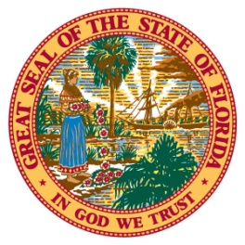
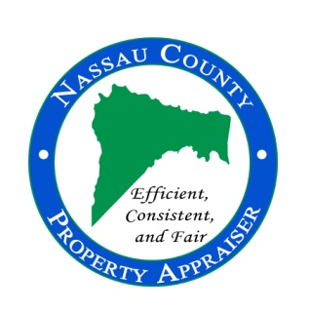
96135 Nassau Place, Suite 4, Yulee, FL 32097 Phone: 904-491-7300 Fax: 904-491-3629 www.nassauflpa.com
OFFICE OF THE
NASSAU COUNTY PROPERTY APPRAISER
A. Michael Hickox, CFA
FOR IMMEDIATE RELEASE June 1, 2021
Contact: Kevin Lilly, 904-491-7302
“Home values in Nassau County are soaring to record levels.”
Nassau County, FL – The primary responsibility for the office of Property Appraiser, is to produce a tax roll which is fair and equitable. Florida Statutes requires us to identify and appraise every parcel in the County to a “Just or Fair Market Value” each year. This is the starting point for Florida’s property tax system and the funding source for local government. In my forty plus years in the real estate and appraisal business, I have never experienced a real estate market like the one we are in currently. Almost every property offered for sale is receiving multiple offers the first few days on the market, resulting in bidding wars and sales prices above the original list price. The record level of appreciation is a direct result of limited supply and increased demand. It is simple supply and demand economics. Inflation has driven building cost to record levels, making existing homes more attractive.
We have a record number of people migrating to Florida from other states due to lock downs, lower taxes, and the ability to work remotely. This has created a shortage of available housing for sale. However, this market is dramatically different than the market we experienced from 2004 to 2008 which produced a collapse of the housing market. The current market is a user’s market opposed to a speculative market which was driven by loose lending practices and over extended borrowers. This market is being driven by low interest rates and buyers with cash looking to improve their quality of life. Tracking and trending sales into the first part of 2021 indicates that next year is shaping up to be even higher. Of course, we will not know until the end of this year.
The lock down in 2020 hurt many small businesses and commercial properties. Our job is to measure what affect the lockdown and loss of business had on the value of the real estate as of January 1, 2021. Some properties are owned and purchased for their ability to produce income. That income drives the value of the real estate. Due to the lockdowns, many income producing properties, such as hotels, restaurants, and movie theaters, lost value due to a forced shutdown. The full-service hotel industry for example, is not expected to reach 2019 income levels until 2024. After considering the reductions in value to some commercial properties as a result of the pandemic, value in Nassau County has still reached record levels.
Due to increased demand for residential properties and new construction, the total market value for the County has reached a new record high of over $17.2 billion. This is over 10.6% above the previous year, and the taxable value has surpassed the previous year exceeding $11 billion, almost 8.5% above last year.
The City of Fernandina Beach is projected to see an increase of 9.1%, bringing their taxable value to about $3 billion.
The Town of Callahan is estimated to have an increase in their taxable value to $122.7 million, up by over 17.8% from last year.
The Town of Hilliard is expected to see about a 9% increase in taxable value, bringing their value to over $115.9 million.
I am often asked, “how do you determine the just or market value of my property?” Florida is a 100% assessment state. Which means we are required to estimate the “fair market value” each year based on the most probable price of the property, as if it were offered for sale in an open market. To do that, we run sales and statistical analysis for different neighborhoods, markets, and property types. We make changes to values based on the sale ratio for those property types, which reflects the sales price compared to the properties current just or market value. Because we appraise in mass and not individual properties like fee appraisers, the Department of Revenue allows us to be within a range of value, not to exceed just or fair market value. Our effective date for value and exemptions is January 1st of each year. Which means this year’s value is based on last year’s sales. Also, to qualify for homestead exemption for this tax year, you must have owned and occupied the property as your primary residence as of January 1, 2021.
Although taxable values have increased County-wide, many property owners are protected by the Save our Homes (SOH) Amendment, which caps the amount the assessed value can increase. Homestead properties can increase no more than 3% or the consumer price index (CPI), whichever is lower. Based on the CPI used for 2021, previously homesteaded properties will see their assessed value increase no more than 1.4% this year. Non-homestead properties have an assessment cap of 10%.
We provided the 2021 estimated values to the taxing authorities on May 28th, so they can begin their budget process using these preliminary figures. They will use these values to help determine their tax rate for the property owners of Nassau County later this summer. I would encourage you to participate in this process. Increases in taxable values will result in higher taxes “IF” the taxing authorities keep or increase their current tax rates.
The “official” preliminary tax roll is expected to be released to the taxing authorities and the Department of Revenue by July 1st. Property owners are encouraged to visit the Property Appraiser’s website at www.nassauflpa.com, in late July to review their 2021 property values. We will send out Truth in Millage (TRIM) Notices in mid-August, which will advise you of what your estimated value, exemptions, and proposed taxes are for 2021. If you have any questions, please contact us at (904) 491-7300.
Thank you for the opportunity to serve as your property appraiser. It is truly an honor and a privilege.
Mike Hickox
###

