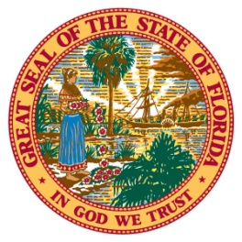
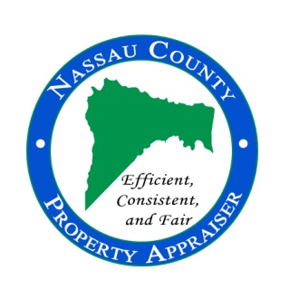
96135 Nassau Place, Suite 4, Yulee, FL 32097 Phone: 904-491-7300 Fax: 904-491-3629 www.nassauflpa.com
OFFICE OF THE
NASSAU COUNTY PROPERTY APPRAISER
A. Michael Hickox, CFA
FOR IMMEDIATE RELEASE May 29, 2020
Contact: Kevin Lilly, 904-491-7302
“Nassau County Property Values Reflect Increase for January 1, 2020”
Nassau County, FL – The Nassau County Property Appraiser’s Office released the 2020 estimated preliminary market values showing an increase for all taxing authorities. These figures reflect the value of property and new construction completed as of January 1, 2020.

According to the Property Appraiser, Mike Hickox, the real estate market in Nassau County continued to increase in value through the end of the 2019 calendar year. Hickox said, “The total market value for the County has reached a new record high over $15.5 billion and the taxable value has also surpassed any previous year in Nassau County exceeding $10.1 billion. This includes a continuation of new commercial and residential construction projects completed during 2019.

Overall, the market remained stable to slightly increasing for most existing property. Once again, the record new construction in the County is driving up the overall taxable value for the taxing authorities. “Our office will be reflecting any impact from the Covid-19 pandemic in the values for next year at this time.” He said, “The real estate market is in the process of adjusting to the economic situation we are currently facing today. As market values change, we will reflect them, as we are required to do, in the subsequent tax roll year. Therefore, the 2021 tax roll will reflect what is happening in the market this calendar year. We still have about half the year to go to see how this year ends.”

Approximately 40% of the over $835 million increase in County-wide taxable value, from the previous year, was a result of new construction completed in 2019. That’s about $335 million in taxable new construction.

The 2020 total market value for Nassau County of $15.5 billion is up approximately 8.85% over the previous year. The market value includes all property before any exemptions, classification reductions, or capped assessments.

Although taxable values have increased county-wide, many property owners are protected by the Save Our Homes (SOH) amendment which caps the amount the assessed value can increase. “Homestead properties can increase no more than 3%, or the consumer price index (CPI), whichever is lower,” said Hickox. “Based on the CPI used for 2020, previously homesteaded properties will increase no more than 2.3% this year.” Non-homesteaded properties are capped at 10%.

In 2020, Nassau County’s taxable value is estimated to be about $10.2 billion, up about 9% compared to last year.

The City of Fernandina is projected to see an increase of 9.3%, bringing their taxable value to above $2.7 billion.

The Town of Callahan is estimated to have an increase in their taxable value to $103 million, up by over 5.3% from last year.

The Town of Hilliard is expected to see about a 7.4% increase in taxable value, bringing their value to slightly over $107 million.

Hickox provided the 2020 estimated values to the taxing authorities on May 29th, so they can begin their budget process using these estimated preliminary figures. They will use the values to help determine their tax rate for the property owners in Nassau County later this summer.

The official preliminary tax roll is expected to be released to the taxing authorities and the Department of Revenue by July 1st. Property owners are encouraged to visit the Property Appraiser’s website at www.nassauflpa.com, in mid-July to view their 2020 property values.

For more information, please contact the Property Appraiser’s Office at (904) 491-7300.

###

