OFFICE OF THE
NASSAU COUNTY PROPERTY APPRAISER
Honorable A. Michael Hickox
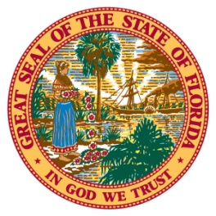

NASSAU COUNTY
Equipment index factors 2020
National Average Florida Department of Revenue
AVERAGE OF ALL

2019 | 1.00
2018 | 1.03
2017 | 1.07
2016 | 1.10
2015 | 1.09
2014 | 1.09
2013 | 1.11
2012 | 1.11
2011 | 1.14
2010 | 1.19
2009 | 1.18
2008 | 1.21
2007 | 1.25
2006 | 1.33
2005 | 1.38
2004 | 1.49
2003 | 1.55
2002 | 1.57
2001 | 1.59
2000 | 1.59
1999 | 1.63
1998 | 1.63
1997 | 1.64
1996 | 1.64
1995 | 1.68
1994 | 1.68
1993 | 1.79
1992 | 1.79
1991 | 1.86
1990 | 1.86
1989 | 1.94

