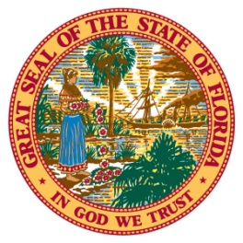
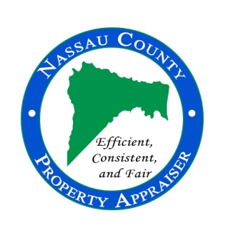
96135 Nassau Place, Suite 4, Yulee, FL 32097 Phone: 904-491-7300 Fax: 904-491-3629 www.nassauflpa.com
OFFICE OF THE
NASSAU COUNTY PROPERTY APPRAISER
A. Michael Hickox, CFA

FOR IMMEDIATE RELEASE January 9, 2020
CONTACT: Kevin Lilly 904-491-7302

“More Opportunities to File for Exemptions”
Nassau County, FL – The Property Appraiser’s Office will be available at various locations around the county so all property owners may have the opportunity to file for exemptions and ask questions.
“Many homeowners have to rearrange their day just to come apply. This is a customer service initiative that will make the process easier and less time consuming for the homeowner,” said Property Appraiser, Mike Hickox.
Our office understands that because of their schedules, people are not able to come into the office to fill out exemption applications. Therefore, we will be present at the Hilliard and Fernandina Beach public libraries and the Callahan and Fernandina farmers markets to assist you with exemptions and questions. The list of dates and times are listed at the bottom of this article.
Homestead exemption is a constitutional guarantee that reduces the taxable value of residential property for qualified residents. If you own property in Nassau County and it is your primary residence, you may qualify for an exemption of up to $50,000 off your assessed value. Per Florida Statutes, homeowners must own and occupy the residence prior to January 1st in order to receive the benefit for the 2020 tax year.

If you are unable to come to the office, or one of the events the Property Appraiser’s Office will be attending, you may still file for homestead online at nassauflpa.com

You may stay up to date on important deadlines and other information by following the office on our Facebook page, A. Michael Hickox, Nassau County Property Appraiser.

The deadline to file for any property tax exemption is March 1st, 2020. For questions, please contact the Property Appraiser’s Office at 904-491-7300.

Location | Date | Time
Hilliard Public Library | January 16th, 2020 | 5:30-7:30pm
Fernandina Beach Public Library | January 16th, 2020 | 5:30-7:30pm
Fernandina Beach Public Library | January 28th, 2020 | 5:30-7:30pm
Hilliard Public Library | January 30th, 2020 | 5:30-7:30pm
Callahan Farmers Market | February 1st, 2020 | 10am-2pm
Hilliard Public Library | February 13th, 2020 | 5:30-7:30pm
Fernandina Beach Farmers Market | February 22nd, 2020 | 9am to 1pm
Fernandina Beach Public Library | February 25th, 2020 | 5:30-7:30pm
Hilliard Public Library | February 27th, 2020 | 5:30- 7:30pm

