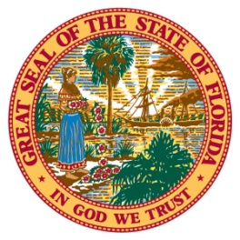
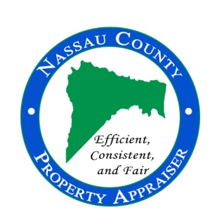
96135 Nassau Place, Suite 4, Yulee, FL 32097 Phone: 904-491-7300 Fax: 904-491-3629 www.nassauflpa.com
OFFICE OF THE
NASSAU COUNTY PROPERTY APPRAISER
A. Michael Hickox, CFA

Additional Resources for Land Management Plans

The below list of contact information is provided as a courtesy from the Nassau County Property Appraiser’s office. These contacts are not affiliated with the office in any way.

James Tootle- Nassau County Forester 904-845-7238
James.Tootle@FreshFromFlorida.com

Jowett & Wood Inc. 904-277-2467

Callahan Timber Company 904-879-3702
800-451-2506

Native Forestry LLLC 904-237-3092 njordan.huntley@gmail.com

EcoWoodsmen LLC 352-650-8539
william@ecowoodsmen.com www.ecowoodsmen.com

