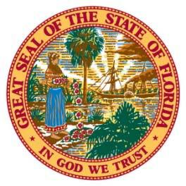OFFICE OF THE

NASSAU COUNTY PROPERTY APPRAISER

Honorable A. Michael Hickox

NASSAU COUNTY

Equipment index factors 2019

National Average Florida Department of Revenue

 | AVERAGE OF ALL
2018 |  | 1.00
2017 | 1.04
2016 | 1.06
2015 | 1.05
2014 | 1.05
2013 | 1.07
2012 | 1.08
2011 | 1.11
2010 | 1.15
2009 | 1.15
2008 | 1.17
2007 | 1.21
2006 | 1.28
2005 | 1.33
2004 | 1.44
2003 | 1.50
2002 | 1.52
2001 | 1.54
2000 | 1.54
1999 | 1.57
1998 | 1.58
1997 | 1.58
1996 | 1.62
1995 | 1.62
1994 | 1.69
1993 | 1.69
1992 | 1.78
1991 | 1.78
1990 | 1.84
1989 | 1.84
1988 | 1.98

